School Overview

The Overview is an outline of your organization. It should address what is most important to Ideal Elementary School, key influences on how the school operates and where the school is headed.

School Overview

Basic description of School
This section should provide information on
- Student enrollment and demographics
- Grade Levels/Departments
- School Improvement Plan
- School vision, mission, values
- School goals
- State School Report Card Summary Results
- Faculty and staff size and demographics
On behalf of the entire Ideal School community, I would like to welcome you to our school. We are thrilled to have you visit and learn more about our community, and eagerly await your feedback around our strengths and opportunities to improve. As part of our ongoing continuous improvement efforts, the Ideal staff has worked diligently to prepare for this visit. We truly appreciate your interest to be a part of this team and willingness to devote two days to support our school improvement process.

Enrollment & Demographics:
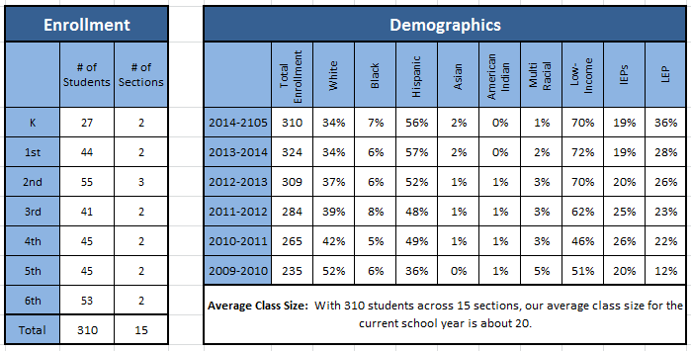

Ideal School’s Mission: Empower students to pursue their interests, talents, and dreams.

Ideal School’s Vision: Ideal School strives to be a high performing school that celebrates the importance of each individual student.
- We want each student to feel that he/she is a valued member of the school community prepared for future academic and career success.
- We want our communities to feel pride in our work and express confidence that we are good stewards of their resources.
- We want each staff member to make a positive difference in the lives of our students and their families.

Ideal School’s Values and Commitments: To guide our behaviors and actions Ideal School states its core values and commitments. We will hold one another accountable for these values and commitments as we strive to achieve our mission and vision.
VALUE | COMMITMENT
We believe the diversity of our communities contributes to our students being successful in our world. | We commit to the development of the “whole child” by meeting the diverse intellectual, social, physical and emotional needs of our students.
We believe students learn in different ways and at different rates as they become self-sufficient in their learning. | We commit to guide students toward self-sufficiency, responsibility and accountability.
We believe education is a shared responsibility of the student, family, school and community. | We commit to forge strong bonds with our parents and communities in our commitment to continuous improvement.
We believe an engaging, innovative, technological learning environment is critical to the learning success for all students. | We commit to integrate technology to enrich and enhance our work and to prepare our students to be knowledgeable and responsible digital citizens.
We believe data and clear information accelerates both teaching and learning. | We commit to use information to make decisions that are in the best interests of our students.
We believe building strong, collaborative school communities are critical to the learning success of our students. | We commit to build strong, trusting, collaborative relationships among all five of our school communities.

Ideal School Goals:
LONG-RANGE GOAL ONE: STUDENT ACHIEVEMENT
GOAL STATEMENT | KEY INDICATORS
All students will demonstrate continuous growth and achieve college and career readiness standards. | - Students are Kindergarten ready.  - Students meet or exceed state ISAT standards in reading and mathematics.  - Students read on grade level by the end of third grade.  - Students achieve annual progress targets in reading and mathematics.  - Students achieve district learning standards in all curricular areas.  - Students make a successful transition to high school.  - Students are challenged and motivated by a rigorous, well-executed curriculum.  - Ideal School’s academic data compares favorably with similar and highest performing schools.  - School academic data improves over time.
LONG-RANGE GOAL TWO: SUPPORTIVE LEARNING ENVIRONMENT
All students will attend school in a safe, supportive and healthy learning environment. | - Students have a sense of belonging and feel safe, respected and free from bullying.  - Students have adults in the school that they feel care about them and that they feel they can go for academic, social, and emotional support.  - Students, families and staff value health and well-being.  - School learning climate survey data improves over time (student, staff and parent).  - Ideal School’s learning climate data compares favorably with similar and highest performing districts.  - Ideal School’s learning climate data improves over time.
LONG-RANGE GOAL THREE: ENGAGED FAMILIES AND COMMUNITIES
Ideal School will enhance learning partnerships by connecting schools, families and communities. | - Parents and community members feel that they are welcomed in the school and that their support and assistance are sought.  - The school and district provide parent learning opportunities and partnerships that contribute to student success.  - Ideal School’s family and community satisfaction data compares favorably with similar and highest performing schools.  - Ideal School’s family and community satisfaction data improves over time.
LONG-RANGE GOAL FOUR: QUALITY STAFF
Ideal School will recruit, retain and develop a high quality, collaborative staff. | - Staff retention is high.  - Staff holds multiple areas of subject area content certification.  - Staff meeting National Board Certification status.  - Staff demonstrates effectiveness.  - Staff demonstrates continued learning (university or in-district approved workshops, coursework, professional development).  - Ideal School’s staff data compares favorably with similar and highest performing districts.  - Ideal School’s staff satisfaction data improves over time.

Goal 1 - Student Achievement: All students will demonstrate continuous growth and achieve college and career readiness standards.
Ideal School uses NWEA (MAP – Measures of Academic Progress) three times a year as benchmark assessments in the areas of reading and math. These assessments serve as grade-level and student data for achievement and fall to spring progress. The results are analyzed and reviewed by grade-levels, sub-groups, and achievement zones. The data are also examined over time, by cohort groups, and compared to benchmark schools.

FY ’14 Spring MAP Data – Ideal School / Benchmark School (provided by NWEA)

ISAT Summary - Performance By All Students, 2012-2014 (IIRC)

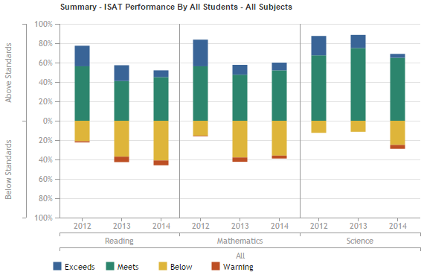

Goal 2 – Supportive Learning Environment: All students will attend school in a safe, supportive, and healthy learning environment.
Ideal Elementary School embraces the philosophy, teaching, and social practices of the Responsive Classroom Model. Responsive Classroom is an evidence and researched-based approach to education that assists teachers as they engage their students in academics, create effective and safe learning environments, and build sincere, kind and supportive learning communities. Although many facets to Responsive Classroom exist, one foundational piece is establishing learning environments that are calm and orderly and that stress the importance of student focus and autonomy. With this key principle in mind, Ideal Elementary has developed clear and consistent social expectations for the common areas of our building. All students have been taught these expectations and are practicing good decision-making each day.

Ideal School has utilized the Positive Behavior Interventions and Supports (PBIS) program for more than 10 years. This is a proactive systems approach for creating and maintaining safe and effective learning environments in schools, and ensuring that all students have the social/emotional skills needed to succeed at school and beyond. The mission of the Illinois PBIS Network is to build skills and capacity of PBIS district and school-based leadership teams through training, coaching and technical assistance. We have three school-wide expectations: Be Safe, Be Respectful, Be Here & Ready.

These two programs are merged together in our school. The attached article describes these two programs and how they work together.
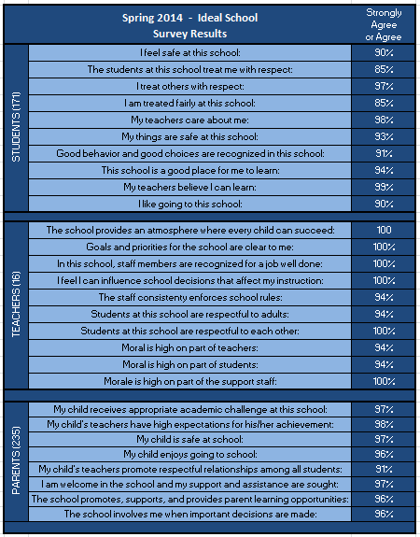

Goal 3 – Engaged Families & Communities: Ideal School will enhance learning partnerships by connecting our school, families, and communities.
We have very supportive and trusting parents and a community that is well connected to our school. We have a very active and supportive PTO. This group sponsors numerous events throughout the school year for students and families. Events such as parent-teacher conferences, all-school meetings, music programs, literacy nights, and other special programs are consistently well attended.
In early 2012, thanks to the efforts of employees from Welch Packaging in Countryside, and an enthusiastic response by school teachers and administrators, a new mentoring partnership began at Ideal School. Now in its fourth year, the Ideal mentoring program now includes twelve mentors and students. Mentors spend an hour a week with their students with a focus on the students’ needs and interests. The program strives to create a bond between the student and the mentor, so that the student will be comfortable talking to the mentor about any problems or concerns he/she has. The mentoring program also helps build students’ social skills and self-esteem. The program surveys show that mentors and their students enjoy their time together and have gained trusting and open relationships. The program has also helped students improve their attendance, grades, and connection with the school.
For the past two years the Ideal School community has participated in our One School. One Book. Family Reading Program. We encourage every family to read the same book together at home. Each family receives a FREE copy of the book which is made available thanks to a generous donation from our friends at Continental Toyota. The goal is that all students from Kindergarten through 6th grade will enjoy reading this book as a family. Students, parents, teachers, and administrative staff will be participating as we aim to build a community of readers.

Goal 4 – Quality Staff: Ideal School will recruit, retain, and develop a high-quality, collaborative staff.
We are committed to a thorough hiring process to find the highest quality teachers for our school. This hiring process, which includes several teachers and three stages, focuses on hiring intelligent candidates who demonstrate a collaborative nature, excellent verbal and written communication skills and above all else, can make great connections with kids. Our retention rate is very high and our staff satisfaction data continues to be very positive.

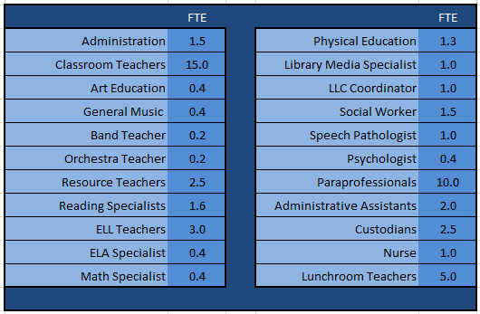

School Specifics
This section should include information, as appropriate:
- Description of school culture/climate
- Major new initiatives
- Recent changes in leadership: administration, teacher leaders, parent leaders
- Introduction of new technologies
- Changes in strategy
- Unique factors
Ideal School is a small neighborhood elementary school (K-6th) in Countryside, Illinois. We are one of four very diverse elementary schools in LaGrange School District 105. Our students move on to attend Gurrie Middle School (D105) and eventually Lyons Township High School (D204). Our school is an important part of the community, and we pride ourselves in creating a caring, supportive, and safe environment for our students and staff members. We work collaboratively to engage our students in meaningful learning experiences to help them accomplish their goals and achieve college and career readiness. We have strong partnerships with various community organizations which support our students, families, and school.
Ideal School – Past & Present
In 1844, the first school was built in this area. The school moved locations in 1858 to the southwest corner of Joliet Road and East Avenue. The school had no name until it became known as The School at Skunk Corners.

In 1886, a new school was built on an acre of land that had been donated. Additions were added to this building in 1896 and 1902. This building burned down in 1918, and a new school was built on the northeast corner of Joliet Road and East Avenue. Students from Hodgkins and Countryside attended this school. When the superintendent inspected the new school, he said it was an ideal school for a rural community. The name stuck. In 1950, the post- WWII baby boom created a need for an additional school, and the current Ideal School was built at this site on 58th Street. There were many students in each class, so Gurrie Junior High was built in 1956 to accommodate the growth.

Today, the population of Ideal School hovers around 300 students, all from Countryside. We serve children from single-family homes, condominiums, apartments, and mobile home parks.

The economic status of Ideal families ranges from the financially comfortable to below poverty level. The ethnicity of students is also diverse. Our student body is primarily comprised of Hispanic, Caucasian, and African American children. There are more than 15 languages spoken by our Ideal families, and our school community represents more than 35 different countries. Transiency is a characteristic of the Ideal School clientele and very unique for the surrounding area.

As a staff this year, we have three major priority focuses: Unit Planning, Balanced Literacy, and ongoing CCSS Implementation. These three things are not separate endeavors but practices that should be used as supportive pieces.

Over the last few years, we have been implementing the Common Core State Standards and engaging in rigorous unit planning for English Language Arts and Math. This is the second consecutive year that an Ideal grade-level team of teachers will attend S.M.A.R.T. Team training. District grade-level teams have spent many hours over the past several months, including numerous days over the summer, working to develop unit plans for this school year. These units were organized around essential questions and themes, and contained pre- and post-assessments that reflect the rigor of the standards. This process has included planning instruction and gathering resources. However, teachers are looking for ways to improve this process so the implementation of each lesson doesn’t have them feeling like they are operating on a day-to-day basis. This process has been exhilarating and exhausting. Teachers are feeling some sense of accomplishment, but understand that this journey will take time.

Connected to the implementation of our unit plans, we are also focusing on providing ongoing professional learning to support a Balanced Literacy approach in our ELA instruction, as well as the implementation of shifting CCSS instructional strategies within ELA and Math.

STEP Assessment Program:
This is the second year that our school has piloted an early literacy assessment program. The STEP assessment program includes several days of professional development for teachers to review and analyze the assessment results, plan instruction for whole-group, small-group, and individual students, and determine how to teach targeted skills through a gradual release process.

Developed in 2004 by the University of Chicago’s Center for Urban School Improvement (USI) and in collaboration with USI teachers, the STEP assessment is a diagnostic and monitoring tool for children’s early literacy development. STEP was developed in response to a need expressed by teachers and researchers for a comprehensive literacy assessment that would evaluate and provide data in the areas of comprehension, reading rates, accuracy, fluency, word level skills, and concepts about print. This comprehensive evaluation provides a set of tools, tightly aligned with scientifically established milestones in reading development, to follow kindergarten through third grades students’ progress. Classroom teachers or reading specialists administer the assessment to students in a one-on-one setting. Each testing session lasts approximately 20-30 minutes per student. At the core of the assessment is a set of leveled texts that increase in difficulty with each “step”. During each individual testing session, the teacher records students’ reading accuracy and fluency, observes their reading behaviors, and engages them in comprehensive conversations about what they have read. Each step also includes assessment components that provide a deeper look into some specific skills that supplement what is learned from students’ oral reading.

In an effort to support classroom teachers and instructional specialists, we have attempted to create large instructional blocks and common planning times in our master schedule. We have dedicated ELA and math blocks, as well as intervention blocks to support our students’ diverse needs and allow for flexible groupings. During these times our support staff pushes into classrooms for additional student support and co-teaching opportunities. This year’s master schedule also includes large blocks of collaboration time for grade-level teams and specialists.

Beginning in the fall of 2013, Ideal School began an important school improvement process where teams determine a greatest area of need (GAN) based on student information and data (Ideal GAN packet is attached). This process has continued into the current school year. The teams plan the implementation of high level strategies, set S.M.A.R.T. goals, and monitor/update those plans with ongoing information throughout the year. A team of Ideal staff members meet three times a year with district office administration to share these plans and celebrate successes.

Other Information:
- Name of Principal
- Names of individuals key to the school system assessment process
- Other information that would be helpful to the assessment team to know about the school.
Principal: Steve Bahn (Ninth year as principal)

CEC Assessment Team:
Focus on Learning | Focus on Collaboration | Focus on Results
Mary Pat Larocca (K) | Shannon Staley (3rd) | Sarah Rusk (2nd)
Megan Hansen (4th) | Libbi Christman (6th) | Gail Housman (4th)
Carolyn Regan (ELL) | Kim Russian (Resource) | Colleen Gjataj (Reading Spec)
SMART Goals Team: Sarah Rusk (2nd), Priscilla Polston (2nd), Barb Hobe (3rd), Shannon Staley (3rd), Gail Housman (4th), Colleen Gjataj (Reading Spec.), Lisa Rodkey (Library Media Spec.), Jennifer Weaver (P.E.), Jen Mindy (Asst. Principal)

Common Core Blackbelt Team: Shannon O’Malley (Reading Spec.), Colleen Gjataj (Reading Spec.), Megan Boyle (5th), Gail Heitz (ELA Spec.), Jen Mindy (Asst. Principal)

PBIS Universal Team: Alba Aguilar (Pre-K),Mary Pat Larocca (K), Alida DelCotto (1st), Vanessa Gentile (1st), Sarah Rusk (2nd), Barb Hobe (3rd), Megan Hansen (4th), Megan Boyle (5th), Steve Speiser (6th), Jake Brewer (P.E.), Jen Mindy (Asst. Principal)

